**Project File-1**

**To demonstrate blind XSS attack**

**Blind XSS:** Blind XSS vulnerabilities are a variant of persistent XSS vulnerabilities. They occur when the attacker input is saved by the web server and executed as a malicious script in another part of the application or in another application.

Target application: <https://xsshunter.com/#/>

Step-1: Create an account in XSS hunter and craft a payload

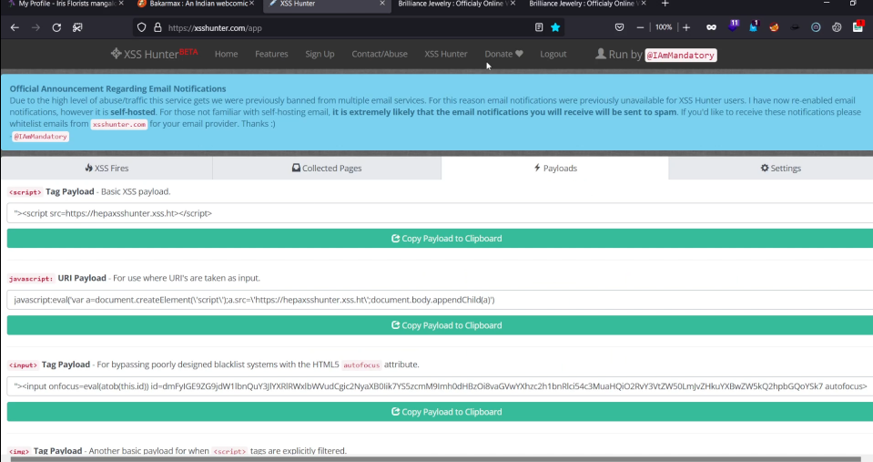

Step-2**:** Take this tag payload on top for demonstration of blind XSS.

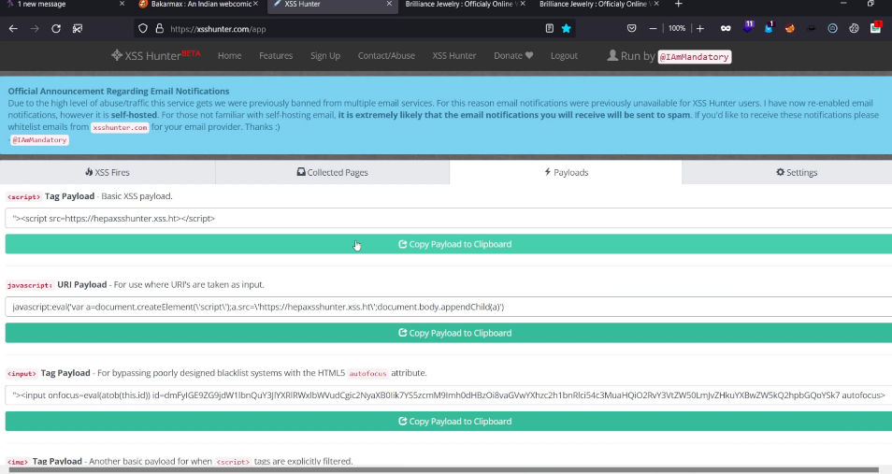

**Step-3:** Create a text document and paste it

Step-5: save it as text.html file and try injecting the payload in search parameter of the website.

**Results for blind XSS:**

Payload got fired on the website which generates results with sensitive information.

